
Yarrunga
Primary
School
Child Safety and Wellbeing Policy
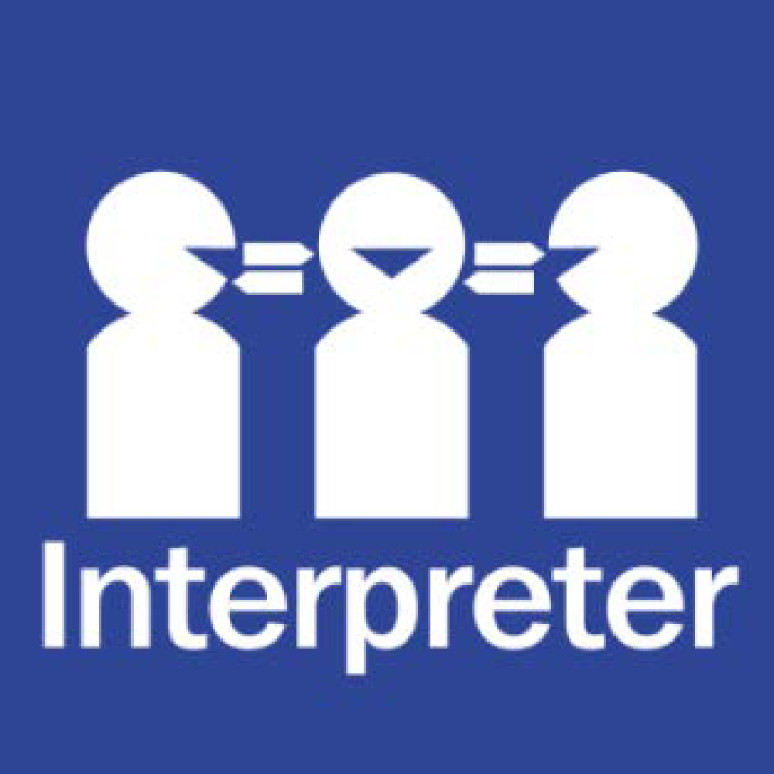
Help for non-English speakers:
If you need help to understand this policy, please contact The Office.

Child Safety and Wellbeing Policy:

Purpose:
The Yarrunga Primary School Child Safety and Wellbeing Policy demonstrates our school’s commitment to creating and maintaining a child safe and child-friendly organisation, where children and young people are safe and feel safe.
This policy provides an overview of our school’s approach to implementing Ministerial Order 1359 (PDF, 363KB) which sets out how the Victorian Child Safe Standards apply in school environments.
It informs our school community of everyone’s obligations to act safely and appropriately towards children and guides our processes and practices for the safety and wellbeing of students across all areas of our work.

Scope:
This policy:
- applies to all school staff, volunteers and contractors whether or not they work in direct contact with students. It also applies to school council members where indicated.
- applies in all physical and online school environments used by students during or outside of school hours, including other locations provided by for a student’s use (for example, a school camp) and those provided through third-party providers
- should be read together with our other child safety and wellbeing policies, procedures, and codes – refer to the related school policies section below.

Definitions:
The following terms in this policy have specific definitions:
- child
- child safety
- child abuse
- child-connected work
- child-related work
- school environment
- school boarding environment
- school staff
- school boarding premises staff
- school governing authority
- school boarding premises governing authority
- student
- volunteer.

Statement of commitment to child safety:
Yarrunga Primary School is a child safe organisation which welcomes all children, young people and their families.
We are committed to providing environments where our students are safe and feel safe, where their participation is valued, their views respected, and their voices are heard about decisions that affect their lives. Our child safe policies, strategies and practices are inclusive of the needs of all children and students.
We have no tolerance for child abuse and take proactive steps to identify and manage any risks of harm to students in our school environments.
We promote positive relationships between students and adults and between students and their peers. These relationships are based on trust and respect.
We take proactive steps to identify and manage any risk of harm to students in our school environment. When child safety concerns are raised or identified, we treat these seriously and respond promptly and thoroughly.
Particular attention is given to the child safety needs of Aboriginal students, those from culturally and linguistically diverse backgrounds, international students, students with disabilities, those unable to live at home, children and young people who identify as lesbian, gay, bisexual, trans and gender diverse, intersex and queer (LGBTIQ+) and other students experiencing risk or vulnerability. Inappropriate or harmful behaviour targeting students based on these or other characteristics, such as racism or homophobia, are not tolerated at our school, and any instances identified will be addressed with appropriate consequences.
Child safety is a shared responsibility. Every person involved in our school has an important role in promoting child safety and wellbeing and promptly raising any issues or concerns about a child’s safety.
We are committed to regularly reviewing our child safe practices, and seeking input from our students, families, staff, and volunteers to inform our ongoing strategies.

Roles and responsibilities:
School leadership team:
Our school leadership team (comprising the principal and Pastoral Care Leader) is responsible for ensuring that a strong child safe culture is created and maintained, and that policies and practices are effectively developed and implemented in accordance with Ministerial Order 1359.
Principals and assistant principals will:
- ensure effective child safety and wellbeing governance, policies, procedures, codes and practices are in place and followed
- model a child safe culture that facilitates the active participation of students, families and staff in promoting and improving child safety, cultural safety and wellbeing
- enable inclusive practices where the diverse needs of all students are considered
- reinforce high standards of respectful behaviour between students and adults, and between students
- promote regular open discussion on child safety issues within the school community including at leadership team meetings, staff meetings and school council meetings
- facilitate regular professional learning for staff and volunteers (where appropriate) to build deeper understandings of child safety, cultural safety, student wellbeing and prevention of responding to abuse
- create an environment where child safety complaints and concerns are readily raised, and no one is discouraged from reporting an allegation of child abuse to relevant authorities.
School staff and volunteers:
All staff and volunteers will:
- participate in child safety and wellbeing induction and training provided by the school or the Department of Education and Training, and always follow the school’s child safety and wellbeing policies and procedures
- act in accordance with our Child Safety Code of Conduct.
- identify and raise concerns about child safety issues in accordance with our Child Safety Responding and Reporting Obligations Policy and Procedures, including following the Four Critical Actions for Schools
- ensure students’ views are taken seriously and their voices are heard about decisions that affect their lives
- implement inclusive practices that respond to the diverse needs of students.
School council:
In performing the functions and powers given to them under the Education and Training Reform Act 2006, school council members will:
- champion and promote a child safe culture with the broader school community
- ensure that child safety is a regular agenda item at school council meetings.
- undertake annual training on child safety, presentation available on PROTECT.
- approve updates to, and act in accordance with the Child Safety Code of Conduct to the extent that it applies to school council employees and members
- when hiring school council employees, ensure that selection, supervision, and management practices are child safe “At our school, school council employment duties are delegated to the principal who is bound by this policy.

Specific staff child safety responsibilities:
Yarrunga Primary School name has nominated a child safety champion in the Principal to implement our child safety policies and practices, including staff and volunteer training.
The responsibilities of the child safety champion are outlined at Guidance for child safety champions.
Our principal is the first point of contact for child safety concerns or queries and for coordinating responses to child safety incidents.
- The Principal is responsible for monitoring the school’s compliance with the Child Safety and Wellbeing Policy. Anyone in our school community should approach the Principal if they have any concerns about the school’s compliance with the Child Safety and Wellbeing Policy.
- The Principal is responsible for informing the school community about this policy, and making it publicly available
- Other specific roles and responsibilities are named in other child safety policies and procedures, including the Child Safety Code of Conduct, Child Safety Responding and Reporting Obligations (including Mandatory Reporting) Policy and Procedures, and Child Safety Risk Register.
Our school has also established a Child Safety and Wellbeing Team and a Student Reference Group on child safety. The Child Safety and Wellbeing Team meet regularly to identify and respond to any ongoing matters related to child safety and wellbeing. The Student Reference Group provides an opportunity for students to provide input into school strategies.
Our Risk Management Committee monitors the Child Safety Risk Register.

Child Safety Code of Conduct:
Our Child Safety Code of Conduct sets the boundaries and expectations for appropriate behaviours between adults and students. It also clarifies behaviours that are not acceptable in our physical and online environments.
We ensure that students also know what is acceptable and what is not acceptable so that they can be clear and confident about what to expect from adults in the school.
The Child Safety Code of Conduct also includes processes to report inappropriate behaviour.

Managing risks to child safety and wellbeing:
At our school we identify, assess and manage risks to child safety and wellbeing in our physical and online school environments. These risks are managed through our child safety and wellbeing policies, procedures and practices, and in our activity specific risk registers, such as those we develop for off-site overnight camps, adventure activities and facilities and services we contract through third party providers for student use.
Our Child Safety Risk Register is used to record any identified risks related to child abuse alongside actions in place to manage those risks. Our school leadership team will monitor and evaluate the effectiveness of the actions in the Child Safety Risk Register at least annually.

Establishing a culturally safe environment:
At Yarrunga Primary School, we are committed to establishing an inclusive and culturally safe school where the strengths of Aboriginal culture, values and practices are respected.
We think about how every student can have a positive experience in a safe environment. For Aboriginal students, we recognise the link between Aboriginal culture, identity and safety and actively create opportunities for Aboriginal students and the Aboriginal community to have a voice and presence in our school planning, policies, and activities.
We have developed the following strategies to promote cultural safety in our school community:
- The inclusion of the Bpangerang Languages Program for all classes for Years Prep to Six
- We have completed an accredited Reconciliation Action Plan.
- All Indigenous Students have Koorie Student Support Group Meetings with the KESO (Koorie Education and Support Officer) present.
- Staff have completed CUST (Cultural Understanding and Sensitivity Training) provided by DET.

To support child safety and wellbeing at Yarrunga Primary School, we work to create an inclusive and supportive environment that encourages students and families to contribute to our child safety approach and understand their rights and their responsibilities.
Respectful relationships between students are reinforced and we encourage strong friendships and peer support in the school to ensure a sense of belonging through implementing our whole school approach to Respectful Relationships, our student Code of Conduct, our school values and other well-being programs.
We inform students of their rights through our whole school approach to Respectful Relationships and give them the skills and confidence to recognise unsafe situations with adults or other students and to speak up and act on concerns relating to themselves or their peers. We ensure our students know who to talk to if they are worried or feeling unsafe and we encourage them to share concerns with a trusted adult at any time. Students and families can also access information on how to report concerns at The Office or to members of the Well-Being Staff.
When the school is gathering information in relation to a complaint about alleged misconduct or abuse of a child, we will listen to the complainant’s account and take them seriously, check our understanding of the complaint, support the student and keep them (and their parents and carers, as appropriate) informed about progress.
Family engagement:
Our families and the school community have an important role in monitoring and promoting children’s safety and wellbeing and helping children to raise any concerns.
To support family engagement, at Yarrunga Primary School we are committed to providing families and community with accessible information about our school’s child safe policies and practices and involving them in our approach to child safety and wellbeing.
We will create opportunities for families to have input into the development and review of our child safety policies and practices and encourage them to raise any concerns and ideas for improvement.

We do this by:
- through the school website, newsletters, other communications, school council and other means
- all of our child safety policies and procedures will be available for students and parents at the Office.
- Newsletters will inform families and the school community about any significant updates to our child safety policies or processes, and strategies or initiatives that we are taking to ensure student safety.
- PROTECT Child Safety posters will be displayed across the school

Diversity and equity:
As a child safe organisation, we celebrate the rich diversity of our students, families and community and promote respectful environments that are free from discrimination. Our focus is on wellbeing and growth for all.
We recognise that every child has unique skills, strengths and experiences to draw on.
We pay particular attention to individuals and groups of children and young people in our community with additional and specific needs. This includes tailoring our child safety strategies and supports to the needs of:
- Aboriginal children and young people
- children from culturally and linguistically diverse backgrounds
- children and young people with disabilities
- children unable to live at home or impacted by family violence
- international students
- children and young people who identify as LGBTQIA+.
Our Student Wellbeing and Engagement Policy provides more information about the measures we have in place to support diversity and equity.

Suitable staff and volunteers:
At Yarrunga Primary School, we apply robust child safe recruitment, induction, training, and supervision practices to ensure that all staff, contractors, and volunteers are suitable to work with children.
Staff recruitment:
When recruiting staff, we follow the Department of Education and Training’s recruitment policies and guidelines, available on the Policy and Advisory Library (PAL) at:
- Recruitment in Schools
- Suitability for Employment Checks
- School Council Employment
- Contractor OHS Management.
When engaging staff to perform child-related work, we:
- sight, verify and record the person’s Working with Children clearance or equivalent background check such as a Victorian teaching registration
- collect and record:
  - proof of the person’s identity and any professional or other qualifications
  - the person’s history of working with children
  - references that address suitability for the job and working with children.
  - references that address suitability for the job and working with children.

Staff induction:
All newly appointed staff will be expected to participate in our child safety and wellbeing induction program. The program will include a focus on:
- the Child Safety and Wellbeing Policy (this document)
- the Child Safety Code of Conduct
- the Child Safety Responding and Reporting Obligations (including Mandatory Reporting) Policy and Procedures and
- any other child safety and wellbeing information that school leadership considers appropriate to the nature of the role.

Ongoing supervision and management of staff:
All staff engaged in child-connected work will be supervised appropriately to ensure that their behaviour towards children is safe and appropriate.
Staff will be monitored and assessed to ensure their continuing suitability for child-connected work. This will be done through regular Performance Reviews and explicit training.
Inappropriate behaviour towards children and young people will be managed swiftly and in accordance with our school and department policies and our legal obligations. Child safety and wellbeing will be paramount.

Suitability of volunteers:
All volunteers are required to comply with our Volunteers Policy, which describes how we assess the suitability of prospective volunteers and outlines expectations in relation to child safety and wellbeing induction and training, and supervision and management. They also sign a undertaking around expected behaviours.

Child safety knowledge, skills and awareness:
Ongoing training and education are essential to ensuring that staff understand their roles and responsibilities and develop their capacity to effectively address child safety and wellbeing matters.
In addition to the child safety and wellbeing induction, our staff will participate in a range of training and professional learning to equip them with the skills and knowledge necessary to maintain a child safe environment.
Staff child safety and wellbeing training will be delivered at least annually and will include guidance on:
- our school’s child safety and wellbeing policies, procedures, codes, and practices
- completing the Protecting Children – Mandatory Reporting and Other Legal Obligations online module annually
- recognising indicators of child harm including harm caused by other children and students
- responding effectively to issues of child safety and wellbeing and supporting colleagues who disclose harm
- how to build culturally safe environments for children and students
- information sharing and recordkeeping obligations
- how to identify and mitigate child safety and wellbeing risks in the school environment.
Other professional learning and training on child safety and wellbeing, for example, training for our volunteers, will be tailored to specific roles and responsibilities and any identified or emerging needs or issues.

School council training and education:
To ensure our school council is equipped with the knowledge required to make decisions in the best interests of student safety and wellbeing, and to identify and mitigate child safety and wellbeing risks in our school environment, the council is trained at least annually. Training includes guidance on:
- individual and collective obligations and responsibilities for implementing the Child Safe Standards and managing the risk of child abuse
- child safety and wellbeing risks in our school environment
- Yarrunga Primary School child safety and wellbeing policies, procedures, codes and practices

Complaints and reporting processes:
Yarrunga Primary School fosters a culture that encourages staff, volunteers, students, parents, and the school community to raise concerns and complaints. This makes it more difficult for breaches of the code of conduct, misconduct or abuse to occur and remain hidden.
We have clear pathways for raising complaints and concerns and responding and this is documented in our school’s Complaint Policy. The Complaints Policy can be found on the school Website or through The Office.
If there is an incident, disclosure, allegation or suspicion of child abuse, all staff and volunteers (including school council employees) must follow our Child Safety Responding and Reporting Obligations Policy and Procedures. Our policy and procedures address complaints and concerns of child abuse made by or in relation to a child or student, school staff, volunteers, contractors, service providers, visitors or any other person while connected to the school.
As soon as any immediate health and safety concerns are addressed, and relevant school staff have been informed, we will ensure our school follows:
- the Four Critical Actions for complaints and concerns relating to adult behaviour towards a child
- the Four Critical Actions: Student Sexual Offending for complaints and concerns relating to student sexual offending
Our Student Wellbeing and Engagement Policy, and Bullying Prevention Policy cover complaints and concerns relating to student physical violence or other harmful behaviours.

Communications:
Yarrunga Primary School is committed to communicating our child safety strategies to the school community through:
- ensuring that key child safety and wellbeing policies are available on our website including the Child Safety and Wellbeing Policy (this document), Child Safety Code of Conduct, and the Child Safety Responding and Reporting Obligations (including Mandatory Reporting) Policy and Procedure
- displaying PROTECT around the school
- updates in our school newsletter
- ensuring that child safety is a regular agenda item at school leadership meetings, staff meetings and school council meetings.

Privacy and information sharing:
Yarrunga Primary School collects, uses, and discloses information about children and their families in accordance with Victorian privacy laws, and other relevant laws. For information on how our school collects, uses and discloses information refer to: Schools’ Privacy Policy.

Records management:
We acknowledge that good records management practices are a critical element of child safety and wellbeing and manage our records in accordance with the Department of Education and Training’s policy: Records Management – School Records

Review of child safety practices:
At Yarrunga Primary School, we have established processes for the review and ongoing improvement of our child safe policies, procedures, and practices.
We will:
- review and improve our policy every 2 years or after any significant child safety incident
- analyse any complaints, concerns, and safety incidents to improve policy and practice
- act with transparency and share pertinent learnings and review outcomes with school staff and our school community.

Related policies and procedures:
This Child Safety and Wellbeing Policy is to be read in conjunction with other related school policies, procedures, and codes. These include our:
- Bullying Prevention Policy
- Child Safety Responding and Reporting Obligations Policy and Procedures
- Child Safety Code of Conduct
- Complaints Policy
- Digital Learning Policy
- Inclusion and Diversity Policy
- Student Wellbeing and Engagement Policy
- Visitors Policy
- Volunteers Policy

Related Department of Education and Training policies
- Bullying Prevention and Response Policy
- Child and Family Violence Information Sharing Schemes
- Complaints Policy
- Contractor OHS Management Policy
- Digital Learning in Schools Policy
- Family Violence Support
- Protecting Children: Reporting Obligations Policy
- Policy and Guidelines for Recruitment in Schools
- Reportable Conduct Policy
- Student Wellbeing and Engagement Policy
- Supervision of Students Policy
- Visitors in Schools Policy
- Volunteers in Schools Policy
- Working with Children and other Suitability Checks for School Volunteers and Visitors

Other related documents:
- Identifying and Responding to All Forms of Abuse in Victorian Schools
- Four Critical Actions for Schools
- Identifying and Responding to Student Sexual Offending
- Four Critical Actions for Schools: Responding to Student Sexual Offending
- Recording your actions: Responding to suspected child abuse – A template for Victorian schools

Policy status and review:
The Principal is responsible for reviewing and updating the Child Safety and Wellbeing Policy at least every two years. The review will include input from students, parents/carers and the community.

Approval:
Created date | June 2024
Consultation | Well-Being Staff, School Council.
Endorsed by | Principal
Next review date | June 2026

